**Blockchain Lab Experiment 6**

**Shashwat Tripathi**

**D20A Roll No: 64**

**Aim:** To develop a web-based gateway that serves as an entry point for users to access and interact with Ethereum Mainnet.

**Code:**

[Colab Code Link](https://colab.research.google.com/drive/1kyWVIxv5GGx3S2_KujWzKzjfGD4BArZu?usp=sharing)

**Etherscan.io**

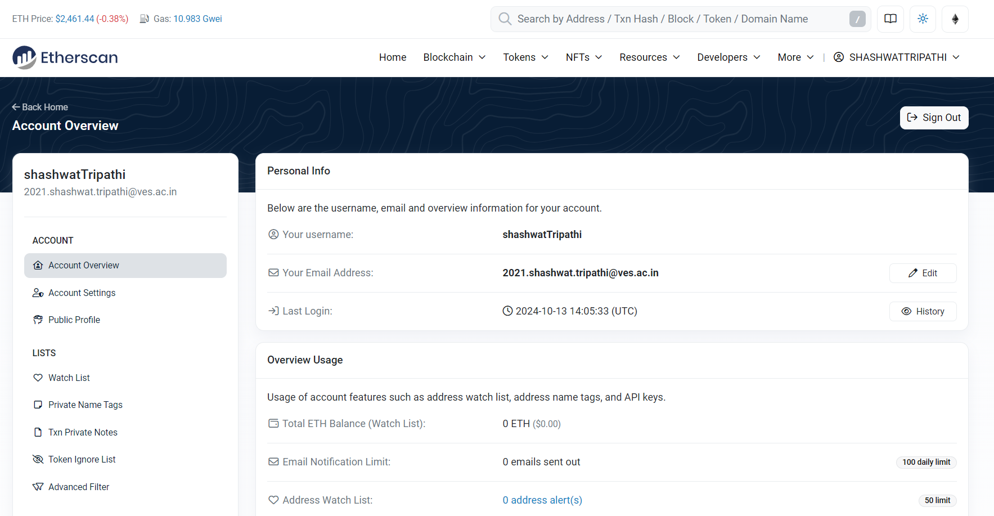

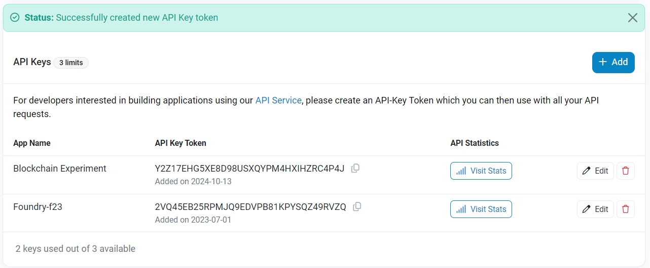

import requests

import datetime

now = datetime.datetime.now()

def get_latest_block(api_key):

url = "https://api.etherscan.io/api"

params = {

"module": "proxy",

"action": "eth_getBlockByNumber",

"tag": "latest",

"boolean": "true",

"apikey": api_key,

}

try:

response = requests.get(url, params=params)

if response.status_code == 200:

data = response.json()

return data["result"]

else:

print("Request failed with status code:", response.status_code)

except requests.RequestException as e:

print("Request failed:", str(e))

return None

api_key = "Y2Z17EHG5XE8D98USXQYPM4HXIHZRC4P4J"

print ("Current date and time : ", now.strftime("%d-%B-%Y"))

latest_block = get_latest_block(api_key)

#print(latest_block)

if latest_block is not None:

print("Latest block information:")

print("Block Number:", int(latest_block["number"], 16))

print("Timestamp:", int(latest_block["timestamp"], 16))

print("Miner Address:", latest_block["miner"])

print("Difficulty:", int(latest_block["difficulty"], 16))

print("Total Difficulty:", int(latest_block["totalDifficulty"], 16))

print("Gas Limit:", int(latest_block["gasLimit"], 16))

print("Gas Used:", int(latest_block["gasUsed"], 16))

print("Transaction Count:", len(latest_block["transactions"]))

print("Transactions:", latest_block["transactions"])

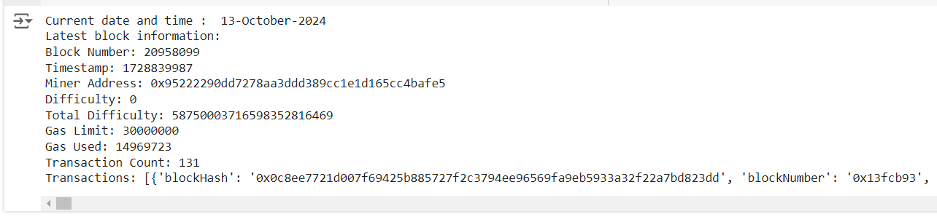

**Infura.io Setup**

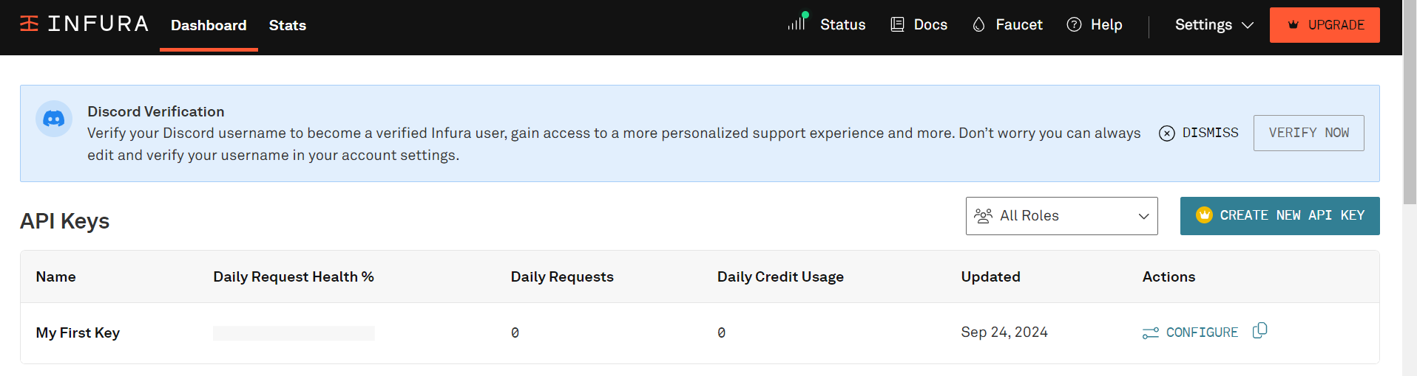

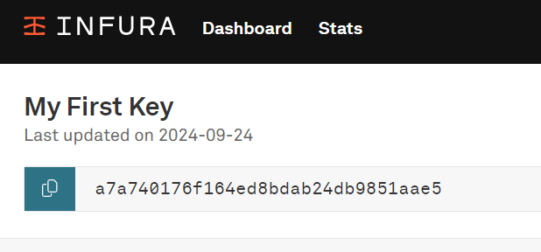

import requests

# Infura HTTP endpoint

infura_url = 'https://mainnet.infura.io/v3/a7a740176f164ed8bdab24db9851aae5'

# Make a request to retrieve the latest block number

response = requests.post(

infura_url,

json={

"jsonrpc": "2.0",

"method": "eth_blockNumber",

"params": [],

"id": 1

}

)

if response.status_code == 200:

result = response.json()

latest_block_number = int(result["result"], 16) # Convert hexadecimal to decimal

print("Latest Block Number:",latest_block_number)

# Print the desired information

print("Miner Address:", latest_block["miner"]) # Error

print("Difficulty:", int(latest_block["difficulty"], 16))

print("Total Difficulty:", int(latest_block["totalDifficulty"], 16))

print("Gas Limit:", int(latest_block["gasLimit"], 16))

print("Gas Used:", int(latest_block["gasUsed"], 16))

print("Transaction Count:", len(latest_block["transactions"]))

else:

print("Failed to retrieve the latest block. Error:", response.text)

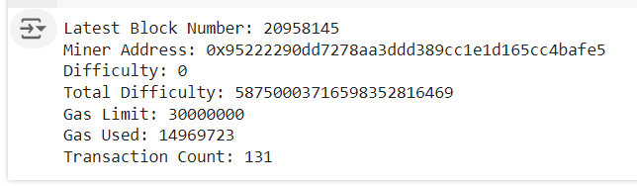

**Conclusion:** Thus, we have developed a web-based gateway that enables users to effectively interact with the Ethereum Mainnet.